

**Tribhuvan University**

**Faculty of Humanities and Social Sciences**

COMPUTER NETWORKING LABSHEETS

A PROJECT REPORT

Submitted to

Department of Computer Application

Shahid Smarak College

*In partial fulfillment of the requirements for the Bachelors in Computer Application*

Submitted by: -

Amir Maharjan

**Internal supervisor**

# Ramu Khadkathoki

# External Supervisor

**Table of content**

|  |  |  |  |  |  |  |
| --- | --- | --- | --- | --- | --- | --- |
| SN | Lab. no | Title of the lab experiment | DATE | Page  No | SIGNATURE | REMARK |
| 1 | Lab 1 | Hardware and Software Specification | 10-03-2080 | 1 |  |  |
| 2 | Lab 2 | Placement of Networking devices | 15-11-2080 | 2 - 3 |  |  |
| 3 | Lab 3 | Types of cables in computer network | 15-11-2080 | 4 - 5 |  |  |
| 4 | Lab 4 | IP Configuration and Share file on network | 20-11-2080 | 6 - 7 |  |  |
| 5 | Lab 5 | Install Packet Tracer and identify the features of Packet Tracer | 20-11-2080 | 8 - 9 |  |  |
| 6 | Lab 6 | Use of VLAN | 21-03-2080 | 10 |  |  |
| 7 | Lab 7 | Configuration of both static and dynamic Routing | 21-03-2080 | 11 - 12 |  |  |
| 8 | Lab 8 | DNS, DHCP, and FTP Services | 22-11-2080 | 13 |  |  |
| 9 | Lab 9 | Implementation of LAN Topology | 22-11-2080 | 14 - 15 |  |  |

**Lab 1**

**Title**

Prepare hardware and software specification for basic computer system.

**Objectives**

To prepare hardware and software specification for basic computer system

**Requirement**

* Hardware
* Processor: i5 12 Gen
* Memory: 8 GB RAM
* Storage: 500 GB HDD and 256 SSD
* Input Devices: Keyboard and Mouse
* Output Deices: Monitor and Printer
* Software
* Operating System: Windows 10
* Application: Cisco Packet Tracer
* Virtual Machine: N / A
* Extension: N / A
* Utilities: N / A

**Lab 2**

**Title**

Brief study of Networking devices (Router, Switch, Hub, Bridge, Repeater)

**Objectives**

To study networking devices like router, switch, hub, bridge, repeater.

**Implementation**

* **Router**

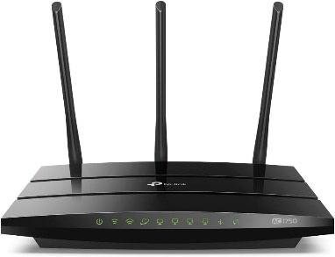

A networking device called a router joins various computer networks. It forwards data packets between various networks while operating at the network layer. Routing tables are used by routers to choose the optimal path for packet delivery. They carry out tasks like DHCP server, wireless access point (Wi-Fi), firewall protection, and network address translation (NAT). Enterprise-grade routers and household routers of many sizes and kinds are available; routers are crucial for effectively regulating data flow between networks.

* **Switch**

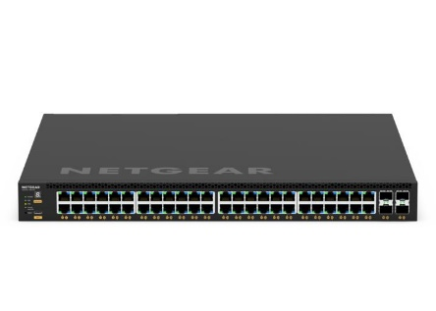

A switch is a networking device that works at the data connection layer (Layer 2) to connect devices inside a local area network (LAN). By forwarding data packets according to their MAC addresses, it minimizes superfluous network traffic. There are two types of switches: managed and unmanaged, with different degrees of configuration and control. They are essential to maintaining dependable and effective communication inside a network.

* **Bridge**

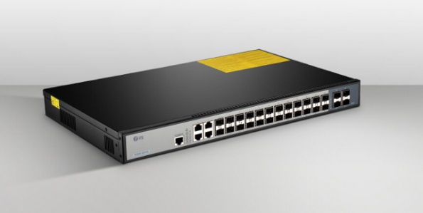

A networking device known as a bridge operates at the data connection layer (Layer 2) and joins two or more network segments. By using MAC addresses to forward data packets, it essentially expands the network. Bridges selectively forward packets to only the relevant segments, hence reducing network congestion. They are necessary for expanding networks and enhancing their general functionality.

* **Repeater**

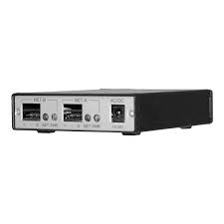

A repeater is a networking device that regenerates and amplifies signals to extend the range of a network. It operates at the physical layer (Layer 1) of the OSI model. By boosting the signal strength, repeaters overcome attenuation and allow data to travel further across the network. They are commonly used in environments where network cables or wireless signals need to cover long distances.

**Lab 3**

**Title**

Types of cables in computer networks and Creating Straight through and Crossover cable.

**Objectives**

To explain types of cables in computer network and create straight through and crossover cable.

**Implementation**

Types of Cables in Computer Networks:

**1. Ethernet Cable (Twisted Pair):**

Category 5e (Cat5e): Commonly used for Fast Ethernet (10/100 Mbps) networks.

Category 6 (Cat6): Supports Gigabit Ethernet (1,000 Mbps) networks with higher bandwidth.

Category 6a (Cat6a): Enhanced version of Cat6, supporting 10 Gigabit Ethernet (10,000 Mbps).

**2. Coaxial Cable:**

Thinnet (10Base2): Thin coaxial cable used in older Ethernet networks.

Thicknet (10Base5): Thick coaxial cable used in older Ethernet networks.

**3. Fiber Optic Cable:**

Single-mode Fiber: Transmits data over long distances with higher bandwidth, typically used in long-haul telecommunications.

Multi-mode Fiber: Suitable for shorter distances with lower bandwidth requirements, often used in LANs.

Creating Straight Through Cable:

Materials Needed:

* Cat5e or Cat6 Ethernet cable
* RJ45 connectors
* Clamping tools

Steps:

* Strip the outer jacket of the cable to expose the twisted pairs.
* Arrange the wires according to the T568B standard (from left to right: orange-white, orange, green-white, blue, blue-white, green, brown-white, brown).
* Insert the wires into the RJ45 connector and ensure they reach the end.
* Use the crimping tool to crimp the connector, securing the wires in place.

Straight Through Cable Connection Diagram:  
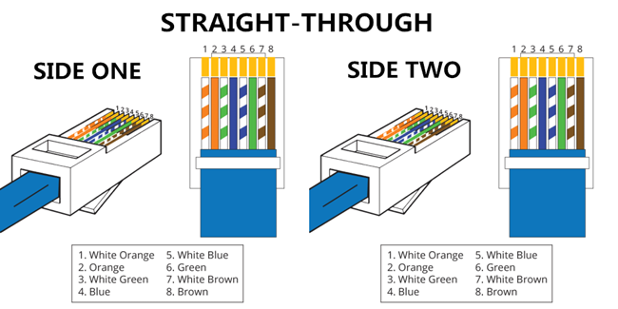

Creating Crossover Cable:

Steps:

* Strip the outer jacket of the cable to expose the twisted pairs.
* Arrange the wires on one end according to the T568A standard (from left to right: green-white, green, orange-white, blue, blue-white, orange, brown-white and brown).
* Arrange the wires on the other end according to the T568B standard (same as straight through cable).
* Insert the wires into the RJ45 connectors and ensure they reach the end.
* Use the crimping tool to crimp the connectors, securing the wires in place.

Crossover Cable Connection Diagram:

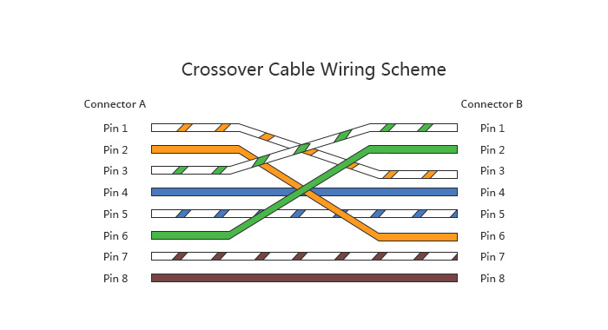

Creating both cables allows for flexible network configurations, connecting devices directly or through intermediary networking equipment.

**Lab 4**

**Title**

Configure the IP address of the computer and create basic network and share file and folder with permission

**Objectives**

To configure the IP address of the computer and create basic network and share file and folder with permission.

**Implementation**

Step 1: Configure IP address of the computer

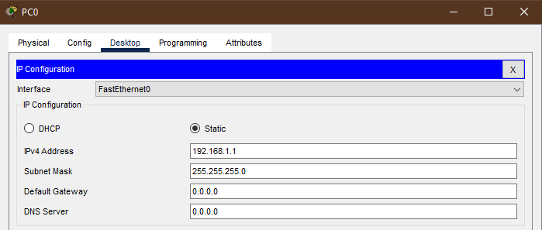

Step 2: Link devices.

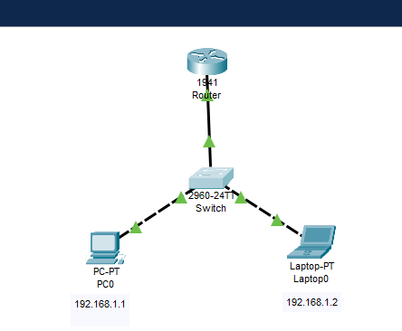

**Result**

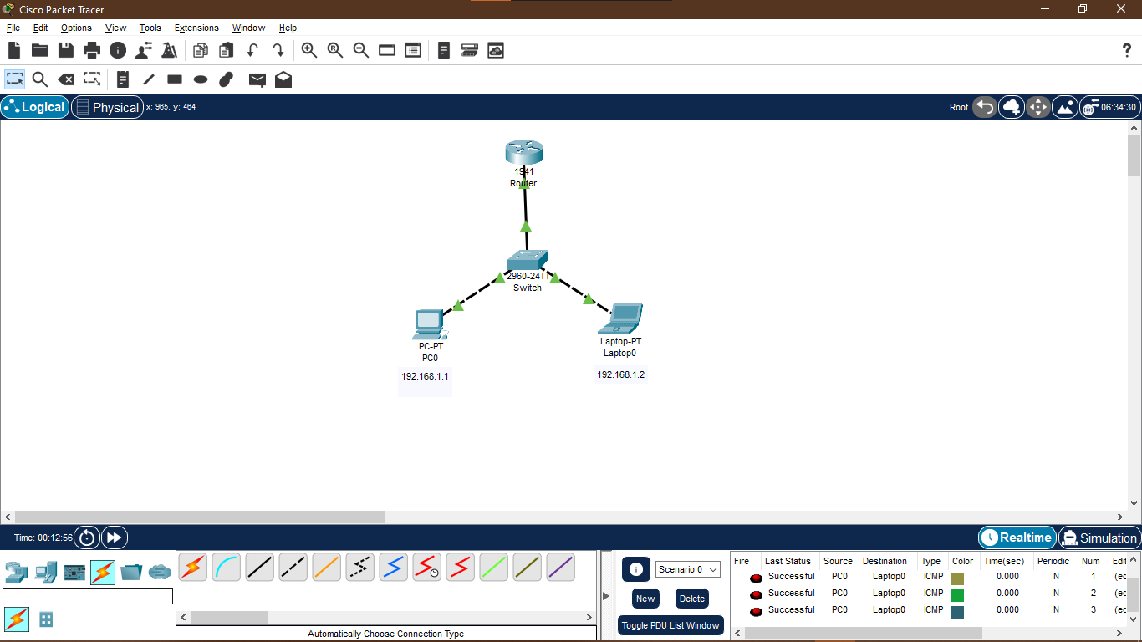

**Lab 5**

**Title**

Install Packet Tracer and identify the features of Packet Tracer

**Objectives**

To install packet tracer and identify the features of packet tracer.

**Implementation**

**Installation of Packet tracer**

* **Download Packet Tracer:** Visit the official Cisco Networking Academy website or authorized Cisco Networking Academy partners to download Packet Tracer. Ensure you have the correct version compatible with your operating system.
* **Install Packet Tracer:** Once the download is complete, follow the installation instructions provided by Cisco. This typically involves running the installer and following the on-screen prompts.
* **Activation:** Some versions of Packet Tracer require activation using a Cisco Networking Academy account. Follow the instructions to activate your copy if necessary.
* **Launch Packet Tracer:** After installation, you can launch Packet Tracer from the desktop shortcut or the Start menu (or equivalent on your operating system).

**Features of Packet Tracer**

* **Network Prototyping:** Packet Tracer allows users to prototype networks by simulating various networking devices such as routers, switches, firewalls, and end devices like PCs and servers.
* **Packet Simulation:** Users can create and send packets within the simulated network to test connectivity, routing, and other network functions.
* **Physical Workspace:** Packet Tracer provides a virtual workspace where users can arrange network devices and connect them using various networking cables and interfaces.
* **Device Configuration:** Users can configure the properties of networking devices such as IP addresses, subnet masks, routing protocols, VLANs, and access control lists (ACLs) using a graphical user interface.
* **Real-time Simulation:** Packet Tracer offers real-time simulation capabilities, allowing users to observe network behavior as they configure devices and send traffic.
* **Activity Wizard:** Cisco provides pre-built networking scenarios and guided activities through the Packet Tracer Activity Wizard. These activities help users learn networking concepts and practice configuration tasks.
* **Collaboration:** Packet Tracer supports collaboration features, allowing multiple users to work together on the same network project in real-time.
* **Assessment and Grading:** In educational settings, instructors can use Packet Tracer to assess student understanding of networking concepts and grade their performance on various activities and assignments.
* **Integration with Cisco Networking Academy:** Packet Tracer is often used in conjunction with Cisco Networking Academy courses, providing hands-on practice for students learning networking technologies.
* **Multi-platform Support:** Packet Tracer is available for Windows, macOS, and Linux operating systems, making it accessible to a wide range of users.

**Lab 6**

**Title**

Implement and demonstrate VLAN in packet tracer.

**Objectives**

To implement and demonstrate VLAN in packet tracer.

**Implementation**

Step 1: Separate the computer into two groups, the groups should be assigned two different networks.

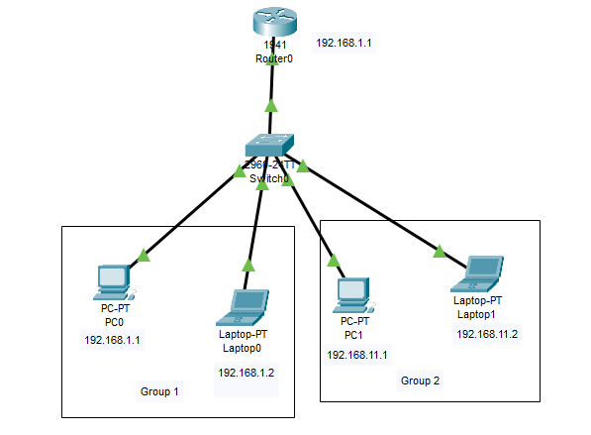

Step 2: Try sending mail file from PC0 to Laptop-PT, should succeed and try sending file from PC0 to PC1, should fail.

**Result**

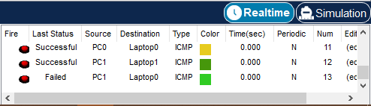

**Lab 7**

**Title**

Implement both static and dynamic router configuration

**Objectives**

To implement both static and dynamic router configuration

**Implementation**

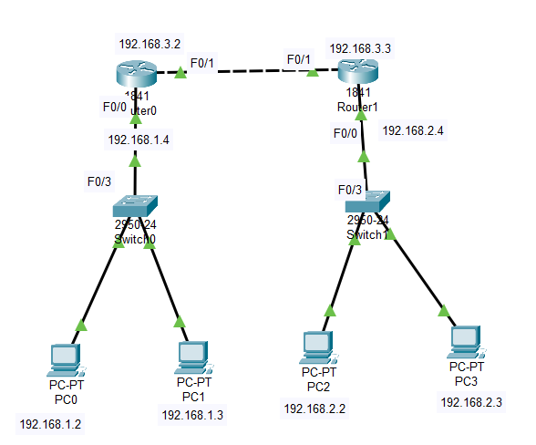

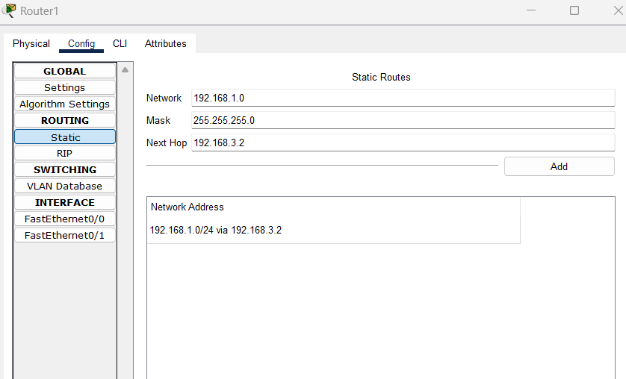

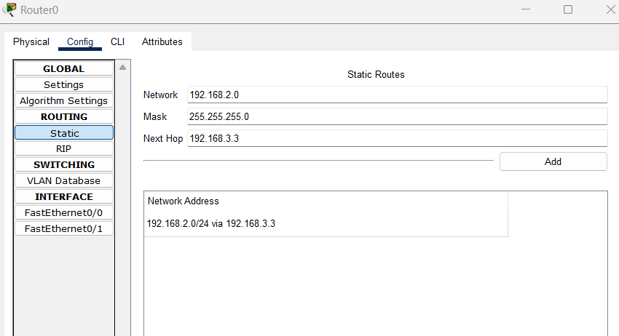

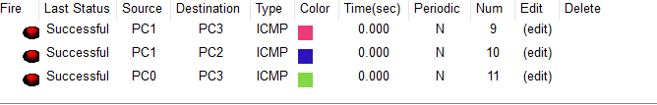

**Lab 8**

**Title**

Implement the Firewall

**Objectives**

To implement the firewall.

**Implementation**

Step 1: select the computer to install firewall on. Firewall interface will show as shown below.

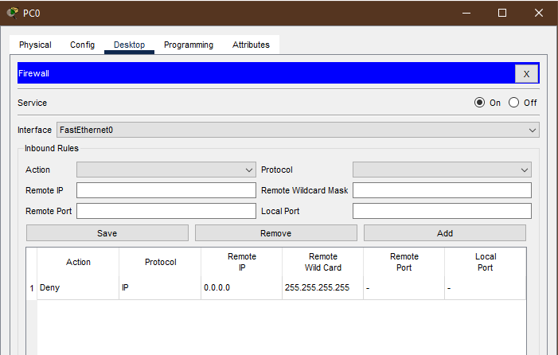

Step 2: Select the action, whether to allow or deny. Add protocol, IP, ICMP, TCP, UDP. Add remote IP and subnet mask.

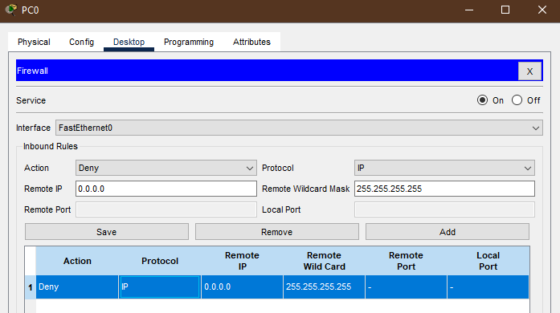

**Lab 9**

**Title**

Configure basic DNS, DHCP, FTP, and web Servers in packet tracer.

**Objectives**

To configure basic DNS, DHCP, FTP and web servers in packet tracer.

**Theory:**

**Definition:**

Dynamic Host Configuration Protocol (DHCP) is a network protocol used to automatically assign IP addresses and network configuration settings to devices on a network

**Uses:**

DHCP automates IP address assignment, subnet mask, gateway, and DNS server configuration, facilitating seamless network connectivity. It simplifies network administration by centrally managing IP address allocation, reducing configuration errors, and supporting dynamic network environments.

**Implementation**

